Brussels 1 June 2015
Joint press release by the European Commission, BirdLife International and IUCN.
Nature alert: “Despite conservation successes in the EU nearly 1 in 5 birds are still at risk of extinction”. The European Red List of Birds, produced by the European Commission and BirdLife International, reveals shocking data: farmland degradation, habitat loss and climate change to blame.

“First the birds, then us. Unless we pay attention, we’ll be on the Red List next. Take note”: these are some of the words in the foreword by novelist Margaret Atwood and poet Graeme Gibson.

After 3 years of work, a consortium led by BirdLife International and financed by the European Commission published today the new European Red List of Birds. The publication will set the base for European conservation and policy work to be done in the coming years. The Red List, that follows the IUCN methodology, is widely recognised as the most authoritative and objective system for assessing the extinction risk of species (1).
According to Karmenu Vella, European Commissioner for Environment, Fisheries and Maritime Policy: "These reports contain some worrying statistics – but they also show the value of well-targeted actions to protect the biodiversity we depend on both economically and socially through the services they provide. Our task is to find ways of building on those successes, and spreading them to other areas. They are also a valuable input to our on-going Fitness Check – Europe needs nature legislation that is fit for purpose”.
According to Iván Ramírez, Head of Conservation at BirdLife International – European and Central Asian Division: “The new European Red List is a call to arms for the conservation of our natural world. It is inspiring to see that many species targeted by conservation efforts, and supported by key tools such as the Birds Directive and the LIFE programme, are recovering. Yet it is shocking to see many species that used to be common and are now listed as threatened. It is deeply worrying to contemplate the possibility of a world with no puffins, turtle doves, lapwings or oystercatchers“.
According to Christina Ieronymidou, the European Species Programme Officer at BirdLife: “The European Red List tells us that we have done a decent job at rescuing the rarest species by protecting their last strongholds and taking actions such as eradication of invasive species and insulation of killer powerlines. But we are now faced with much bigger challenges, from the ecological degradation of our farmland to climate change. These problems require a much broader and deeper response”.
According to Craig Hilton-Taylor, Head of the Red List Unit, IUCN Global Species Programme:“ The Red List data provides a solid baseline for monitoring future trends in European biodiversity and for guiding conservation actions. The European Red List of Birds clearly shows the need for constant vigilance and increased action if we are to prevent the loss of biodiversity in Europe”.
The key findings in the report (2) are:
- 18% of the 451 species assessed are threatened at EU27 level. This means 82 species, of which 11 are Critically Endangered, 16 Endangered and 55 Vulnerable.
- 13% of the 533 species assessed are threatened at European level. That makes a total of 67 species, of which 10 are Critically Endangered (the highest threat level). Among them some iconic and popular birds such as: Sociable Lapwing, Yellow-breasted Bunting, Slender-billed Curlew and Balearic Shearwater. The study also found that 18 species are Endangered and an additional 39 Vulnerable.
- Negative trends: a total of 29 species have been uplisted since 2004 (formerly considered to be of Least Concern but are now threatened or Near Threatened in Europe). Here we find species such as European Turtle-dove, Eurasian Oystercatcher, Atlantic Puffin, Razorbill, Meadow Pipit, Willow Grouse, Black-legged Kittiwake and Common Pochard. Some species that were identified as being in trouble a decade ago have still not improved: Egyptian Vulture, Aquatic Warbler, Northern Lapwing, Greater Spotted Eagle and Little Bustard.
- Improvements: a total of 20 species were previously considered regionally threatened and are now classified as Least Concern in Europe (although some are still globally threatened). These include some very charismatic species, such as Dalmatian Pelican, Ferruginous Duck, Eurasian Thick-knee, Black Kite, Lesser Kestrel, Long-legged Buzzard, Gull-billed Tern, Arctic Loon and Great Bustard. Another 25 species are still threatened in Europe, but now have a lower extinction risk than a decade ago, and have seen their threat level downlisted. For example, Zino’s Petrel and Azores Bullfinch, both previously considered to be Critically Endangered, are now classified as Endangered.
ENDS

NOTES TO THE EDITOR

(1) BACKGROUND INFO
The IUCN Red List is widely recognised as the most authoritative and objective system for assessing the extinction risk of species. Although it was primarily developed for global use, it can also be applied at regional and national levels, following IUCN's Regional Red List Guidelines. BirdLife International is recognised by the IUCN as the Red List authority for birds.
The IUCN Red List of Threatened Species™ provides taxonomic, conservation status and distribution information on plants, fungi and animals that have been evaluated using the IUCN Red List Categories and Criteria. This system is designed to determine the relative risk of extinction, and the main purpose of the Red List is to catalogue and highlight those taxa that are facing a higher risk of extinction (i.e. those listed as Critically Endangered, Endangered and Vulnerable). The IUCN Red List also includes information on taxa that are categorised as Extinct or Extinct in the Wild; on taxa that cannot be evaluated because of insufficient information (i.e., are Data Deficient); and on taxa that are close to meeting the threatened thresholds (i.e., are Near Threatened).
Since 2005, the European Commission has financed European Red Lists for all terrestrial vertebrate groups, except birds, and for several other taxa, such as molluscs, bees, medicinal plants etc. During 2012–2015, a Commission-funded project – led by BirdLife International, and involving a consortium including the European Bird Census Council, Wetlands International, IUCN, BTO, Sovon, RSPB, Czech Society for Ornithology and BirdLife Europe – has filled this gap for birds. The new European Red List of Birds offers a state of the art assessment of risk of extinction for all bird species naturally occurring in Europe, from the Atlantic to the Ural mountains. BirdLife has combined the official data reported by EU Member States under Article 12 of the Birds Directive with equivalent data collated and provided by BirdLife Partners and other key collaborators in virtually every other country in Europe, and assessed the regional extinction risk of every regularly occurring species using IUCN Regional Red List Guidelines.

(2) Key findings
- Out of 533 species assessed at pan-European level, 67 (13%) are threatened with regional extinction, and 6 species are already extinct (since 1800). 10 are Critically Endangered, 18 Endangered, 39 Vulnerable and 32 are classified as Near Threatened.

All photos available for download in high resolution here.

Critically Endangered

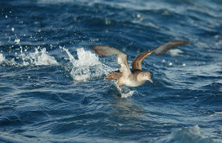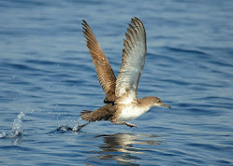
Balearic Shearwater: this seabird has a tiny breeding range on Spain’s Balearic Islands, and a small population (3,193 breeding pairs) which is undergoing an extremely rapid population decline owing to a number of threats, in particular predation at breeding colonies by introduced mammals and at-sea mortality as a result of fisheries by-catch.

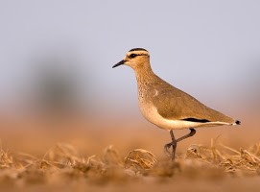
Sociable Lapwing: This wader nests on the central Asian steppes and winters in NE Africa, Arabia and NW India. It used to breed in Ukraine and southern European Russia, but has lost most of its breeding grounds in our region to agricultural expansion, and is now down to just a few pairs in European Russia. In its last strongholds in Kazakhstan it is threatened by the loss of grazing animals needed for habitat maintenance, while hunting is a cause of concern on passage and in winter.

Endangered

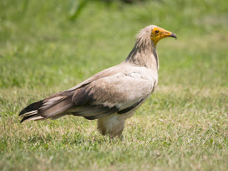
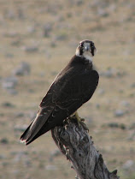
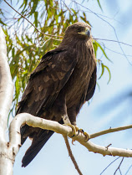
Greater SpGreater Spotted Eagle nests in mature riverine forests in Eastern Europe, and is declining owing to extensive habitat loss and persistent persecution.

Lanner Falcon is threatened by disturbance at its breeding cliffs in the Mediterranean and loss of extensive agriculture habitat.

Egyptian Vulture is highly vulnerable to poisoning, both in the Mediterranean breeding grounds and on its African wintering grounds. It also falls victim to electrocution on powerlines, shooting and loss of extensive agriculture habitat.

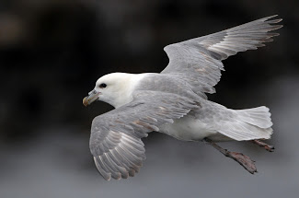
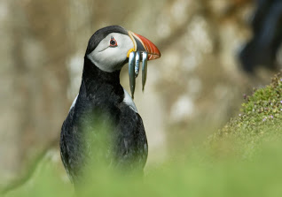
Two once very common seabirds have now joined the Endangered list: Atlantic Puffin and Northern Fulmar are iconic birds of the North Atlantic seabird colonies but recently their populations have started plummeting under the combined blows of overfishing and climate change.

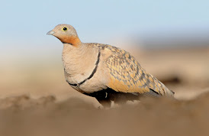
Black-bellied Sandgrouse has declined owing to extensive loss of its steppe habitat in Iberia and Turkey. The large scale conversion of dry grasslands and traditional dryland cereals to intensive agriculture is driving declines in a whole suite of species across the Mediterranean.
Vulnerable
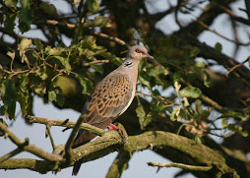
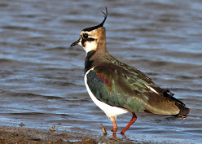

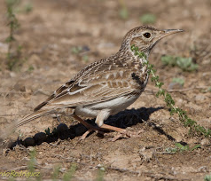

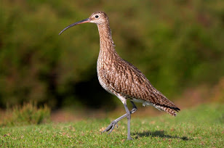
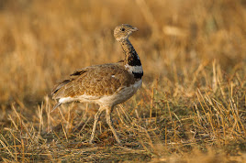

This category includes some formerly very common farmland birds which have collapsed, mainly due to farming intensification. These include European Turtle-dove, Northern Lapwing and Eurasian Curlew, plus rarer species like Little Bustard and Dupont’s Lark.

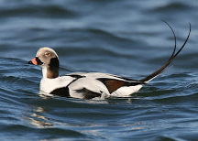
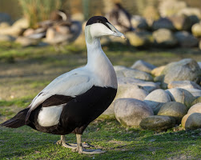
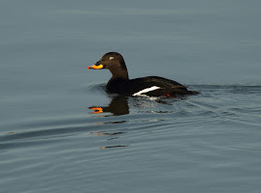

A suite of seaducks, including Common Eider, Velvet Scoter and Long-tailed Duck, are all Vulnerable in Europe, principally owing to declines recorded in their Baltic and North Sea wintering grounds, but potentially driven by a range of threats in both their Arctic breeding grounds, as well as on passage and in winter.
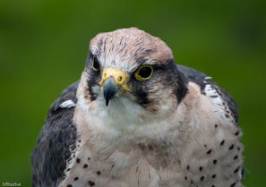
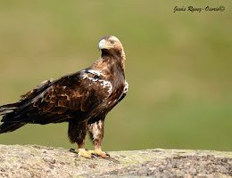
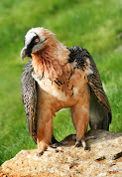

Several charismatic raptor species are recovering due to intensive conservation work but are still classified as Vulnerable. These include the Spanish Imperial Eagle (still one of the world’s rarest raptors), the Bearded Vulture and Saker Falcon.

Conservation Success Stories
Among the doom and gloom there are some inspiring conservation successes. Intensive conservation work has brought back from the brink several species, that while still rare and classified as Endangered are staging a spectacular comeback.
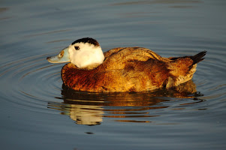
White-headed Duck was reduced to 22 birds in Spain, its last redoubt in our region in 1977. Now there are nearly 2,000.

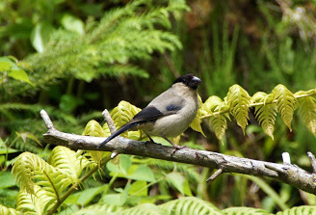
Azores Bullfinch was driven to the edge of extinction on Sao Miguel, the only island where it occurs, mainly by the impact of invasive alien vegetation that had overran its native forests. Habitat restoration spearheaded by the BirdLife Partner SPEA has brought the species back, allowing it to be downlisted from Critically Endangered to Endangered, with the population bouncing back from 40 to around 400 pairs.

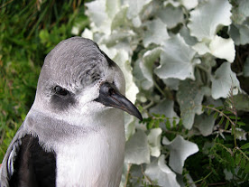
Similar efforts (mainly predator control and habitat restoration following a fire) have saved in the nick of time Zino’s Petrel, one of the world’s rarest seabirds, whose global population of 65-80 pairs nests on a few ledges on one mountain in Madeira, which has also been downlisted from Critically Endangered to Endangered.

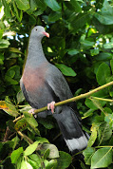
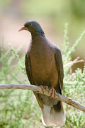
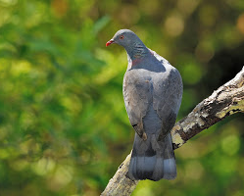

Madeira Laurel-pigeon and the Dark-tailed and White-tailed Laurel-pigeons, endemic species of Madeira and the Canary Islands, respectively, suffered historical declines because of destruction of their laurel forest habitat. Thanks to successful conservation action, mainly focused on protection and restoration of laurel forest, the species have been downlisted (Madeira and Dark-tailed Laurel-pigeons from Near Threatened to Least Concern, and White-tailed Laurel-pigeon from Endangered to Near Threatened).

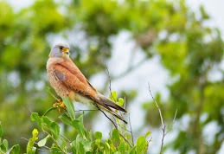
Lesser Kestrel declined in the second half of the 20th century because of habitat loss and degradation, but the declines slowed and eventually halted largely as a consequence of actions implemented following the development of a Species Action Plan and increased resources to implement this, including full legal protection in all relevant EU countries, management of breeding colonies, provision of artificial nest boxes, maintenance of foraging habitats through agri-environment schemes, and awareness-raising activities. The species was downlisted from Vulnerable to Least Concern.
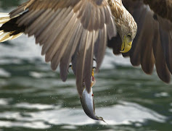
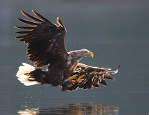
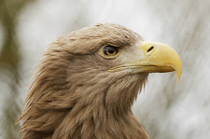

White-tailed Sea-eagle has shown a spectacular recovery in Europe following historical declines. Thanks to legal protection and the ban of harmful chemicals, the species has been downlisted from Near Threatened to Least Concern.

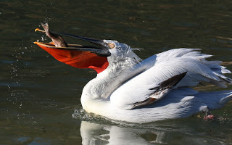
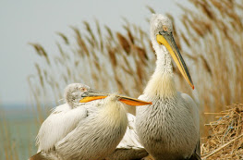

Dalmatian Pelican suffered large declines in the last centuries due to habitat loss and degradation and persecution, but thanks to habitat management and restoration the population in Europe is recovering and the species was downlisted from Vulnerable to Least Concern in Europe (although it is still globally threatened, owing to declines in Central Asia).

